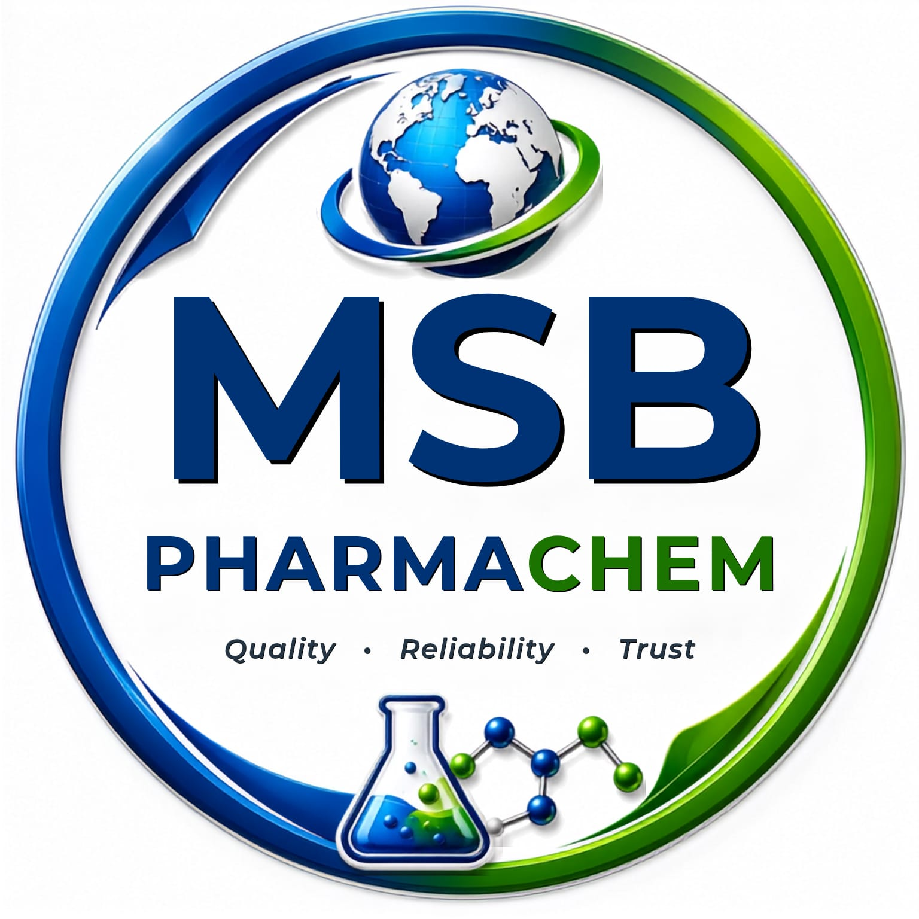
About Us: MSB PHARMACHEM
Quality Products, Global Supply

Welcome to MSB PHARMACHEM
MSB PHARMACHEM is a trusted supplier of Pharmaceutical APIs, Bulk Drugs, Pharma Raw Materials, Excipients, Domestic Chemicals, Solvents and Impurity Standards. From our base in Kukatpally, Hyderabad, we serve pharmaceutical manufacturers, formulation companies and chemical industries across India and international markets.
Our name stands on three promises: Quality, Reliability and Trust. Every enquiry, order and shipment we handle is guided by them.

Who We Are
Hyderabad is one of the world's leading pharmaceutical hubs, and it is where MSB PHARMACHEM was built. Our team brings more than 18 years of experience in supply chain management, inventory planning, procurement and vendor coordination. This lets us do more than supply materials. We plan, source and deliver with the discipline that pharma customers expect.
We work as an extension of our customers' procurement teams. We understand that a delayed or inconsistent batch affects production schedules, so we focus on dependable availability, clear documentation and honest communication.

What We Supply

Active Pharmaceutical Ingredients (APIs)
Human and veterinary APIs for generic formulation manufacturers.

Pharma Raw Materials & Intermediates
Raw materials and intermediates supplied in consistent quantities for production needs.

Excipients
Pharmaceutical excipients that meet the needs of formulation and manufacturing teams.

Chemicals & Solvents
Industrial, laboratory and pharma-grade chemicals and solvents for pharma, agro and allied industries.

Impurity Standards
Reference and impurity standards that support analytical development and quality control.

Our Reach: Local Roots, Global Supply
- Across India: We supply pharma and chemical manufacturers with prompt dispatch and dependable logistics.
- Around the World: We support international buyers with export-ready documentation and compliance-conscious processes. We are steadily expanding our global network, with Southeast Asia as a key focus.

Why Customers Choose Us
- Quality You Can Verify: Products are supported by proper documentation, including COA and MSDS, and sourced from vetted suppliers.
- Supply Chain Strength: Experienced planning means fewer delays and steady availability.
- Fair, Transparent Pricing: Direct sourcing relationships help us quote competitively and clearly.
- Compliance-Focused: We follow regulatory and documentation requirements for domestic and export shipments.
- Quick, Responsive Service: You get fast quotations and a team that responds.
- Flexible Order Sizes: We handle everything from trial quantities to bulk volumes.

Our Mission
To be a dependable partner to the pharmaceutical and chemical industry, delivering quality products and honest service that help our customers grow.

Our Vision
To become a leading Indian pharma and chemical sourcing company with a strong presence in global markets.

Our Core Values
- Quality: We never compromise on the standards our customers rely on.
- Reliability: We deliver what we promise, when we promise it.
- Trust: We build long-term relationships through integrity and transparency.

Get in Touch
Looking for a specific API, raw material or chemical? Contact us for product specifications, samples and quotations.
Address: Plot No. 128, Kamala Prasanna Nagar, Allwyn Colony, Kukatpally, Hyderabad – 500072
Phone: 9063922242
Email: [your email]

